Join Twin Cities Carifest..
32nd Anniversary of the Caribbean Festival

Twin Cities Carifest began as a grass-roots celebration of the Caribbean cultural heritage of many residents in the Twin Cities. Now in its 32nd year, Carifest has grown to provide festivalgoers of all ages and backgrounds, the ultimate arts fusion experience: featuring colorful, Caribbean flare, danceable live Calypso, Reggae and Chutney beats; a growing vibrant costume parade and more—each element as diverse as the islands themselves.

Carifest has grown every year and is planning for continued growth in 2025. Individuals and businesses recognize the value of the community enriching event that promotes a greater respect for diversity and inspires visitors of all ages.

We invite you to join in support of this festival by becoming a 2025 Twin Cities Carifest Sponsor, supporter, attendee, or volunteer.

Carifest Facts
When: Carifest - Caribbean Outdoor Cultural Festival, Sat., July 26, 2025, 10 a.m. to 10 p.m.
‘Always the fourth weekend in July’
Where: West River Parkway between Plymouth and Broadway, Minneapolis
Highlights: Live bands; dance; Mas’ (Masquerade) Parade; Caribbean Food Specialties; Arts & Crafts Market; children’s activities and contests
Audience: Multicultural, spanning all ages; sun, fun and spectacle worshippers; live music fans; food adventurers; travel/culture buffs, networking and people watchers - a family friendly affair.
Attendance: Approximately 10,000 attendees in 2024 from surrounding states and Canada
Fantastic Friday Fundraiser: Caribbean Jam ticketed fundraiser at the Knights of Columbus, Bloomington, Twin Cities Venue, Friday, July 25, 2025, featured performances by local & International Artists & Venue to be named **, DJ’s :- 8 p.m. – 2 a.m.
Festival Saturday:
A wonderful mix of international & local live bands, along with community performers provide continuous musical & dance performances throughout the day. The vast array of Caribbean culinary offerings will prove irresistible.

Beneficiary: Carifest, with a portion of event proceeds to the Caribbean Disaster Relief Fund,
Educational Scholarship Fund is in the works.
Information& Requests - Contact:
Program Director - James Byron, jsbtap@yahoo.com, 612-239-8384
And do visit us online at www.carifest.org, join us on FB: TwinCitiesCarifest, Email: twincitiescarifest@gmail.com.

.Carifest. Sponsor Opportunities .
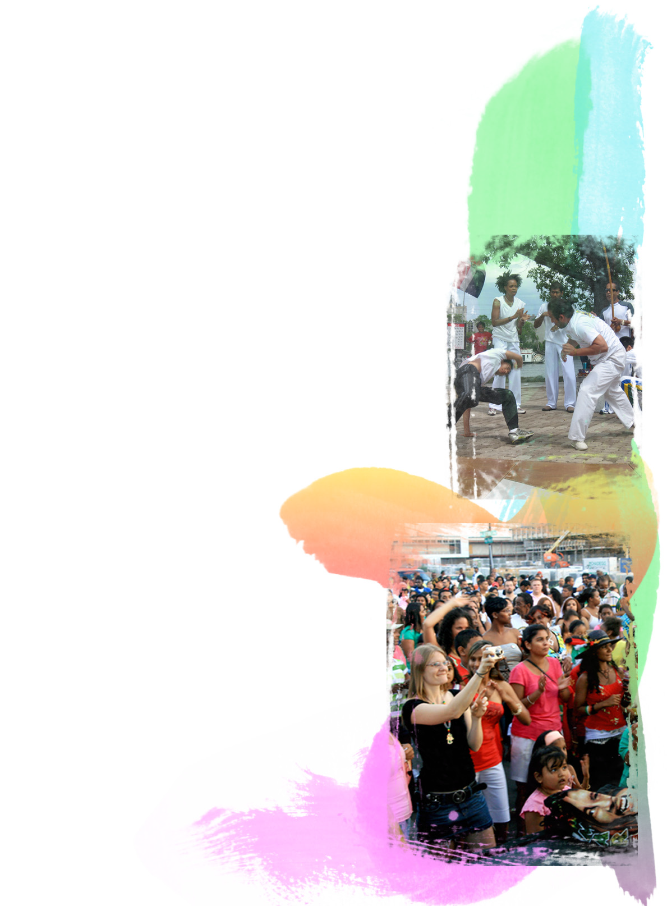
“Fantastic Friday” - Caribbean Jam Title Sponsor: $10,000, July 25
• Naming rights to Fantastic Friday - Caribbean Jam kick-off fundraising party
• Inclusion in all print and broadcast advertising, promotional
materials, signage, poster and official t-shirt
• Major program listing
• 15 passes to Caribbean Jam sponsor reception
Twin Cities Carifest Title Sponsor: $20,000,
July 26 at Carifest
• Naming rights to Twin Cities Carifest, outdoor festival
• Inclusion in all print and broadcast advertising, promotional
materials, signage, poster, official t-shirt and official water bottle
• Signage in parade
• Major program listing
• 15 passes to ‘Fantastic Friday’ sponsor reception
• Sampling/Selling rights at “Caribbean Village” festival market
Main Stage Music Sponsor: $15,000
• Sponsor name/logo on stage signage
• Inclusion in all print and broadcast advertising,
promotional materials, signage, poster and official t-shirt
• Program listing
• 10 passes to Caribbean Jam sponsor reception
Beverage Tent Sponsor: $10,000
Note: no alcohol can be brought on to park property;
however, there is an opportunity for one alcohol vendor
sponsor to set up a tent in the street.
• Naming rights to tent
• Inclusion in advertising, promotional materials,
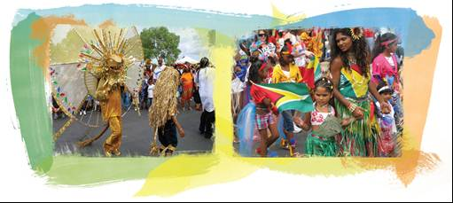
signage and official t-shirt
• Signage
• Major listing in program
• 10 passes to Caribbean Jam sponsor reception

More Carifest Sponsor Opportunities…
“Mas” (Masquerade) Parade Sponsor: $7,500
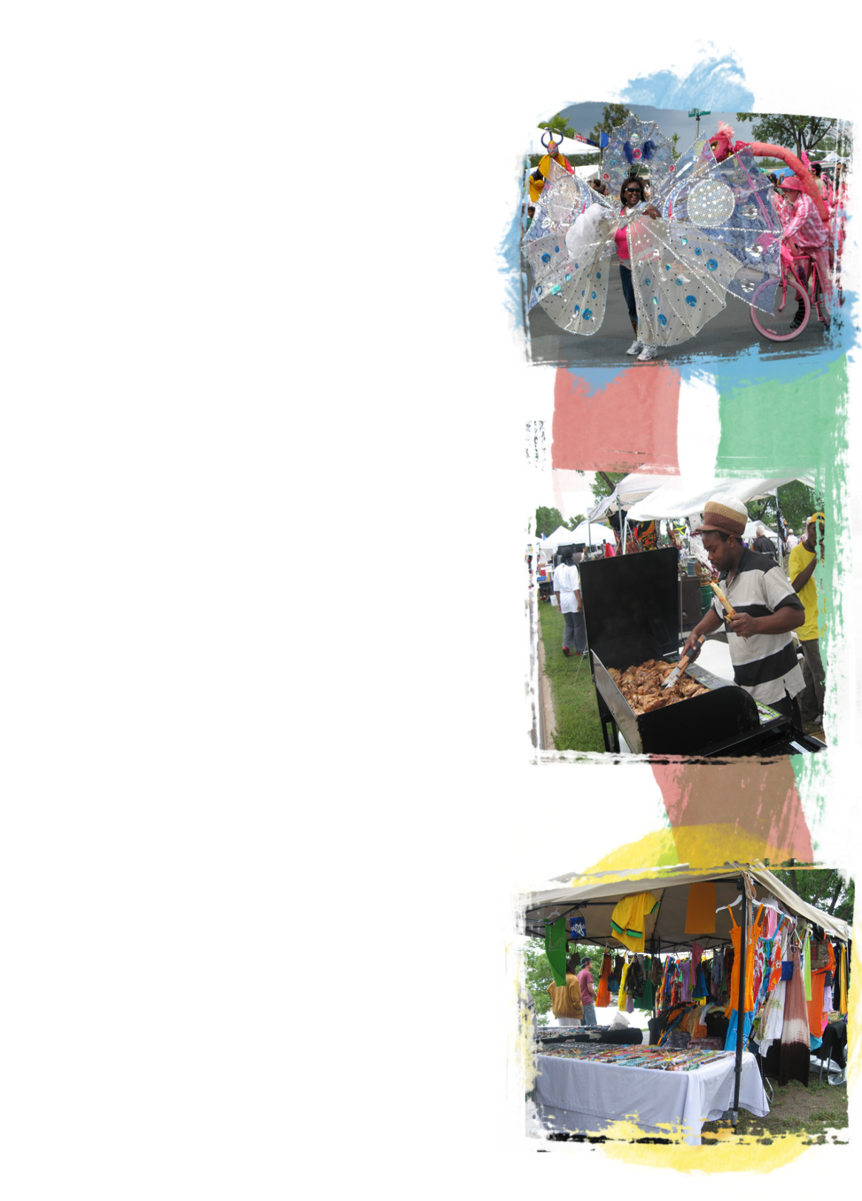
• Inclusion in all print and broadcast advertising,
promotional materials, signage, poster and official t-shirt
• Parade banner
• Program listing
• 5 passes to Caribbean Jam sponsor reception
Children’s Activity Area Sponsor: $5,000
• Inclusion in all print and broadcast advertising,
promotional materials, signage, poster and official t-shirt
• Listing in program
• 5 passes to Caribbean Jam sponsor reception
Reggae Sponsor: $7,500
Soca Sponsor: $7,500
Chutney Sponsor: $7,500
• Included in print advertising, poster and official t-shirt
• Listing in program
• 5 passes to Caribbean Jam sponsor reception
Mas’ Costume Sponsor: Sections & Individual
King Costume – 4 Available $3000
Queen Costume 4 Available $3000
Section Sponsor $1500 -$2500
please call for sponsorship info

• Inclusion in parade banner
• Program listing

All Sponsors will be listed on our radio station “Carifest Media Works”

• T-shirt listing
• Passes to Caribbean Jam sponsor reception

Thank you for your consideration!

2025 Carifest Exposures…..

Partners receive the following exposure…
Logo or name inclusion on the appropriate media:
- Event Level billing as Carifest ………
- Print: Minimum of two full-color ads in
City Pages or similar entertainment publications
- Television Promotion: minimum of four weeks on the Comcast broadcast
- Radio: minimum of four weeks of radio spots on three Twin Cities Radio Stations
- Web Promotion: 4 months & up to one year Logo inclusion and link on the carifest.org page.
- E-mail Blasts: Logo inclusion in Carifest List, sent up to 10,000 members &,
partner subscribers to promote the event.
- Advertising Cards: imprints on 10,000 cards distributed across the Twin Cities.
On-site Presence…
- Booth space on site for product sampling
- Opportunity to include an item in 100 VIP Swag Bags
- Opportunity for branded 10,000 A wrist bands
- Opportunity to roll out new promotions
- Logo inclusion on large banner at the event stages
- Logo inclusion on Main banner and section banners during the parade
- Logo on Carifest parade entry in the 2025 Mpls Aquatenial Torchlight Parade*
Additional Benefits…
- Opportunity to align your organization with a great community sponsored event
- Opportunity to brand your business name, product, or
services to thousands of people through additional

2025 Carifest – 32nd Annual
Fantastic Friday – July 25
Multiple Performing Artists- to be named.
(8pm-2am)

Carifest festival – July 26 - (10a-10p)
West River Parkway (Plymouth – Broadway)

2025 Twin Cities Carifest Donation Form
Yes, I will Sponsor the Twin Cities Carifest at the ________________________ level!
Please make checks payable to “Twin Cities Carifest”, a 501(c) (3) organization. Contributions are tax deductible as allowable by law.
Please add “Sponsorship Level” in Memo line.

Name_____________________________________________________________
Company or Affiliation _______________________________________________
Address ___________________________________________________________
City___________________________________ State_________ Zip__________
Email _____________________________________ Phone __________________
Form of Payment: check credit card
Credit card (VISA/MasterCard/Amex) ____________________________________#
_____________________________________ Exp. Date______
Authorized Signature___________________________________
Mail to:
Twin Cities Carifest
Attn: Mr. James Byron, President
Mr. Charles Peterson, Treasurer
100 South First Street, PO Box 580481,
Minneapolis, MN 55458-0481
Deadline for camera-ready materials for use in promotional advertising is May 1, 2025. Please email your vector logo in EPS format to James Byron, jsbtap@yahoo.com, 612-239-8384
A portion of proceeds from Carifest will go to Caribbean Disaster Relief Fund, Caribbean Book Shelf program, providing free books to youngsters in the Caribbean, Ragoo Scholarship Fund.
Questions?
Program Director: James Byron, jsbtap@yahoo.com, 612-239-8384
Charles Peterson, charles.peterson@yahoo.com
General Info: Email: twincitiescarifest@gmail.com
Online at: www.carifest.org or Facebook- Twin Cities Carifest

